TEMPERATURE LOGGING
Temperature-depth profiles were measured and recorded at four White Sands Test Facility (WSTF) monitor wells and eight White Sands Missile Range (WSMR) wells of varying types using high-precision temperature logging equipment. The logging gear consists of a thermister probe attached to a reel-mounted, four-conductor, cable. Measurement accuracy is ±0.01°C. Because the probe equilibrates quickly in the water column, temperatures were measured at 2 m intervals in these zones. In contrast, measurements made above the water column take much longer due to slow equilibration times, and can be affected by transient air currents, especially near the top of the well, that diminish accuracy. Therefore, measurements in the air column were taken at coarser intervals (typically 5-25 m), depending on depth to water and the time available for logging a given well.
The WSTF monitor wells are pumped occasionally using low-volume pumps to obtain water samples, but none had been pumped for at least several weeks prior to temperature logging. The pumps in these wells were carefully removed to minimize disturbance of the static water and air columns that might affect temperature measurements. These wells were then left static for several days to re-equilibrate from any disturbance caused by removing the pumps. Therefore, it was assumed that all the wells were at static formation temperatures when logged. The pumps were reinstalled after logging and water samples were taken for geothermal analysis. Well depths ranged from 54.9 to 115.3 m. The profiles in these wells appear to be primarily conductive in nature and are generally similar (Figure X [NASA Composite T-D Plot]). Gradients from the linear segments at the bottom of each well range from about 22°C/km (well 300-B-166) to 59°C/km (well 100-G-223). Multiplying typical thermal conductivity values for the reported lithology at the bottom of each well suggests that heat flow is lowest in well 300-B-166 (40 mW/m²) and highest in well 100-G-223 (100 mW/m²). Heat flow values for wells 700-A-253 and 100-F-358 are approximately 70 and 90 mW/m² respectively. However, thermal conductivity can vary greatly, so the uncertainty in these heat flow estimates may be on the order of ±20% or more. The reason for the much lower heat flow in well 300-B-166 is unclear, but could be related to cooler groundwater flow, or greater uncertainties in thermal conductivity estimates or reported lithologies.
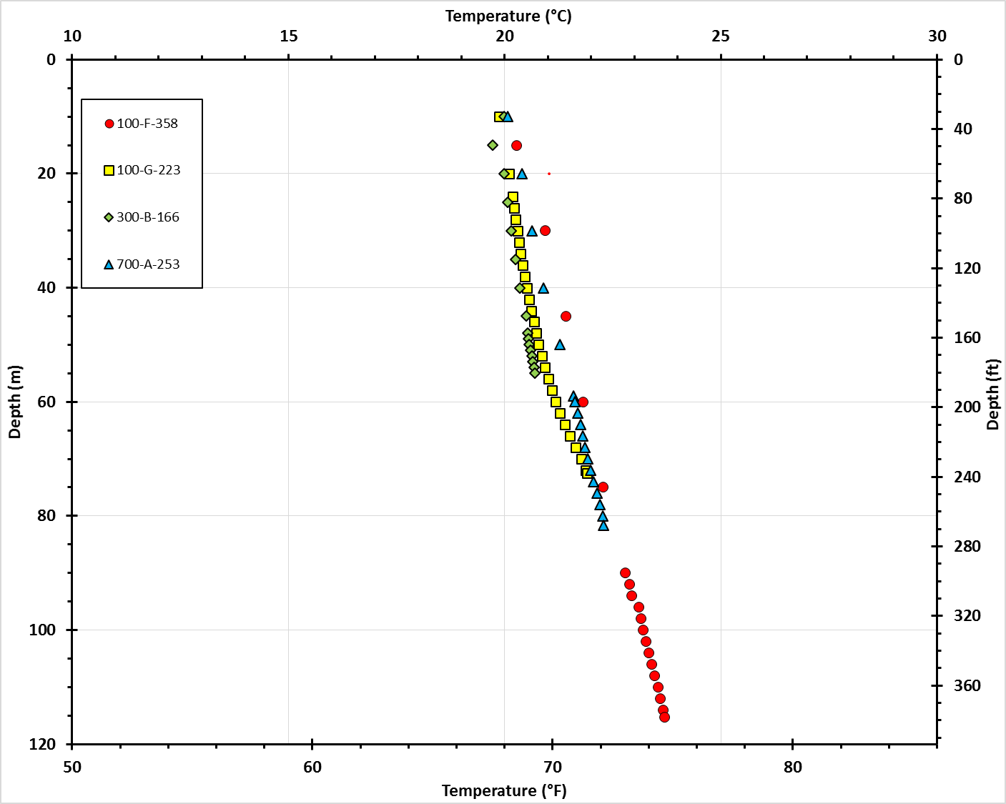
Figure X. Temperature-depth plot for wells that were logged in the WSTF area.

The WSMR wells consisted of monitor wells, primary water supply wells that are normally pumped, but had the pumps removed for maintenance/well rehabilitation, abandoned supply wells used for construction projects (one of which was apparently plugged at about 15 m and was consequently not useful to the study), and a supply test well. Most of these wells can be considered as “wells of opportunity” and were logged based more on accessibility than location. Locations ranged from south of the main WSMR cantonment to the Stallion Range Control area in the northern part of the WSMR range. A number of additional wells were checked for logging suitability that could not be logged for various reasons. As far as could be determined, all of the wells had been static for quite some time and were assumed to be at thermal equilibrium. However, it is possible that pumping the SMR-1 supply well about 35 m from the logged SMR-1 Test well could cause a thermal disturbance. Unlike the WSTF wells, pumps are not installed in the WSMR monitor wells that were logged, so there were no issues with disturbing the wells prior to logging. Sample intervals varied in the same way and for the same reasons as in the WSTF wells. The temperature-depth plots are much more varied than those of the WST wells (Figure Y [WSMR Composite T-D Plot]). Profiles for all of the wells appear to be primarily conductive. An apparent equipment malfunction near the bottom of SW-20 is likely responsible for a small positive shift in the profile. Logged depths range from 71 to 147 m. Some of the wells are deeper than the logging depth indicates, but could not be logged to the full depth due to obstructions. Gradients vary from 15°C/km (Ted well on Stallion Range) to 73°C/km (Unnamed construction well). Lithologic data are not currently available for any of these wells, so heat flow estimates cannot be made with any degree of certainty.
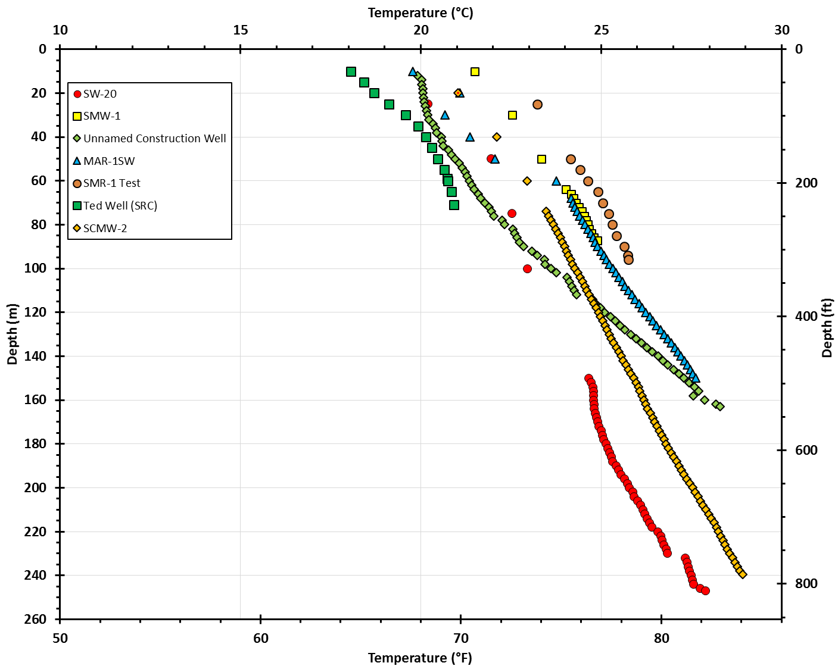
Figure Y. Temperature-depth plot for wells that were logged in the WSMR area. Equipment malfunction is the probable reason for the offset at 230 m in supply well SW-20.

WATER SAMPLING [Stuart should look at this section]
Water samples from were obtained from nine WSTF monitor wells, six WSMR water supply wells, and 11 private water supply wells west of the WSMR range near the main cantonment. Standard sampling procedures were used to obtain samples to analyze for dissolved gasses, stable isotopes, and geothermometry. The low-volume pumps in the monitor wells and slow recharge, prevented purging the recommended three casing volumes of water from the WSTF wells. However, the wells were purged long enough that temperatures and conductivity were stabilized to ± 0.2°C and ± 3% respectively. The private supply wells near WSMR use relatively low volume pumps (most are solar-powered), but had generally been running long enough to adequately purge prior to sampling and had stable temperature and conductivities. With the exception of the ORC (Oscura Range Center) and Herbie supply wells, the high-volume WSMR supply wells had been pumping sufficiently long for adequate purging. The ORC well is used for construction and field use, produces less water, and had been off for an unknown period of time. The pump was started and allowed to run until temperature and conductivity measurements were stable prior to sampling. The Herbie well had no provision to take samples prior to the water being pumped into a large storage tank. Therefore samples had to be taken from water that had been held in the storage tank for some period of time. Although the well is used frequently, it could not be determined how long the water samples had been held in the tank. Water chemistry results are summarized in Table X [Table of Geochemical Analysis].

